Real Estate Company Process Improvement

Recommendation Document

April 14, 2020, v1

Contents

Introduction 3

Current Process and Challenges 3

Monthly Financial Reporting Process 3

Data Consolidation and Analysis 3

Marketing Palm Place Villa 3

New Process 4

Semi-automated Monthly Financial Reporting 4

Automated Data Consolidation and Analysis 5

Visualize Data on Google Data Studio 5

Approach to Market Palm Place Villa 7

Why do you market Palm Place Villa? 7

Things the Real Estate Management company should do to market? 7

Approach to attracting sponsors 9

# Introduction

Smart IT Technologies is an IT consulting firm and has been approached by a Real Estate Management company from Las Vegas to improve their monthly operational processes and tools.

# Current Process and Challenges

The Real Estate Management company specializes in luxury short term rentals and most of the bookings are made through Airbnb. There are ~60 units in the portfolio so monthly reporting and weekly processes are quite manual. The current process involves the following steps:

## Monthly Financial Reporting Process

Every month the financial analyst at the Real Estate Management company pulls transaction history from a variety of portals. The financial analyst processes the data and formats it in a specific way and upload it to Google Drive. There are certain challenges in the current business process, like:

* Prone to human errors
* Time consuming
* Knowledge transfer and time to learn in case of employee turnover

## Data Consolidation and Analysis

To manage the day-to-day operations, the financial analyst at the Real Estate Management company creates and consolidates various files related to Notes, Maintenance, Cancellations and Cleaning. There are certain challenges within this process:

* Lack of automation to collect the data
* Manual and prone to errors
* No structured data to access and analyze statistics

## Marketing Palm Place Villa

The Real Estate Management company currently has limited, or no marketing process defined and with no sponsors it’s difficult to promote their villa and excel against competitors. This includes the following problems:

* No digitization
* Expensive print media
* Can’t reach wide customer base

# New Process

The Agile team at Smart IT Technologies spent good amount of time to understand the business process and its challenges and ideated over defining and executing solution. The new process looks as follows:

## Semi-automated Monthly Financial Reporting

Every month the Financial Analyst would download the financial reporting files from various portals and run the Formatting macro set up on their system. The input file should have predefined columns and in sequence. Once the analyst runs the macro against the file, the processed file would have additional columns like Occupancy Tax and Total Amount.

Once the Macro is executed, save the macro formatted file in a specific folder named **Monthly Financial Reporting** on the system.

Also, upload the monthly file on Google Drive in the **Monthly Financial Reporting** folder.

Once the file is uploaded, run the **runmarket.bat** and **runupload.bat** files to merge all the files saved on the local **Monthly Financial Reporting** folder and upload data to a Google Sheet, that could be used to populate the dashboards on Google Data Studio.

## Automated Data Consolidation and Analysis

The Financial Analyst would use the Google forms to add and collate data for Notes, Maintenance, and Cleaning for a Unit.

Google Forms could be accessed at:

* **Notes**: <https://forms.gle/jkHv4depQ9DKZS8f8>
* **Maintenance**: <https://forms.gle/MdEHXDh4989EYRwFA>
* **Cleaning**: <https://forms.gle/iGvuogzBedLDGpT26>

Any data entry added to these individual forms will be saved on a Google Sheet.

These individual Google Sheets are added as Data Source to a Data Studio dashboard.

## Visualize Data on Google Data Studio

URL: <https://datastudio.google.com/s/vQjDxow92PE>

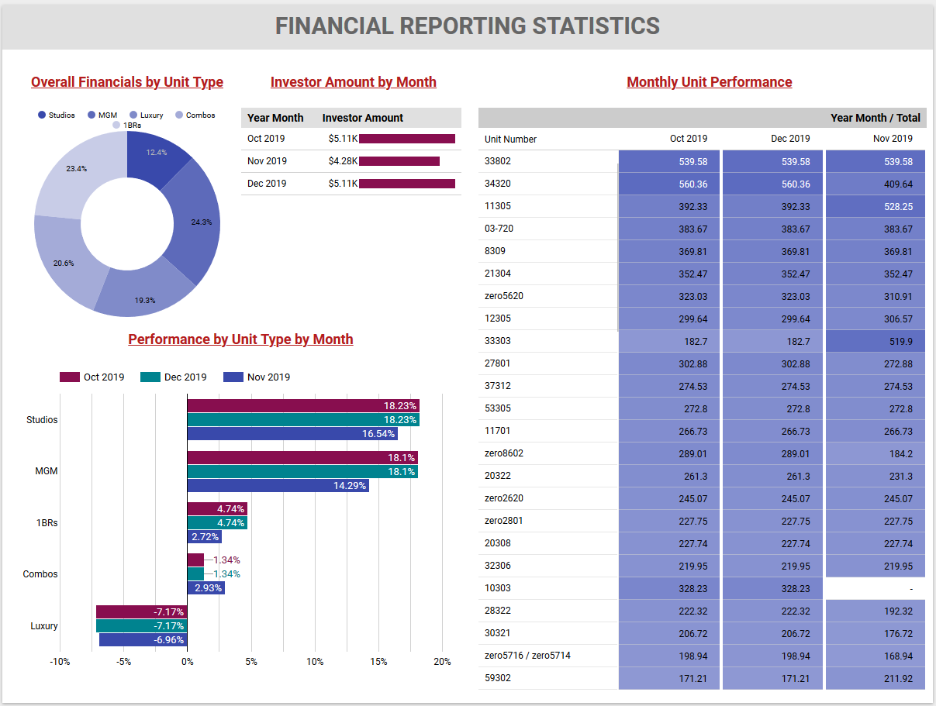

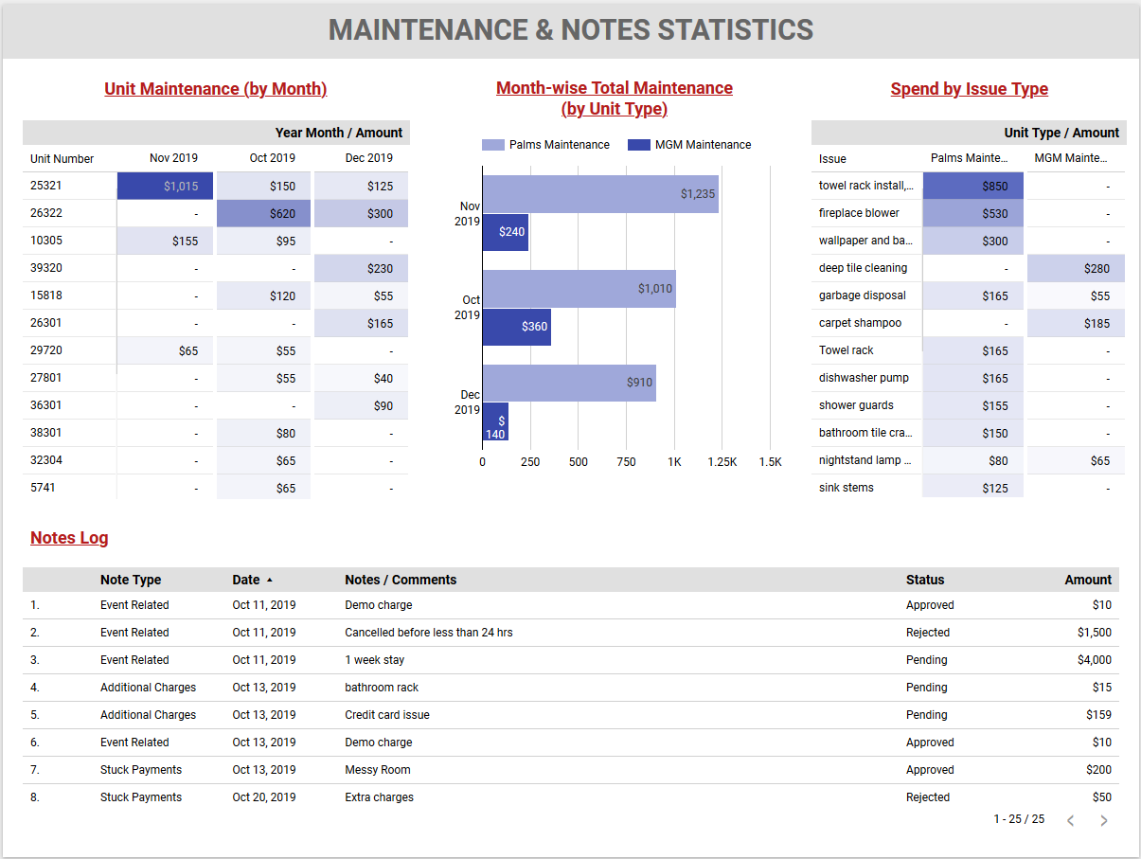

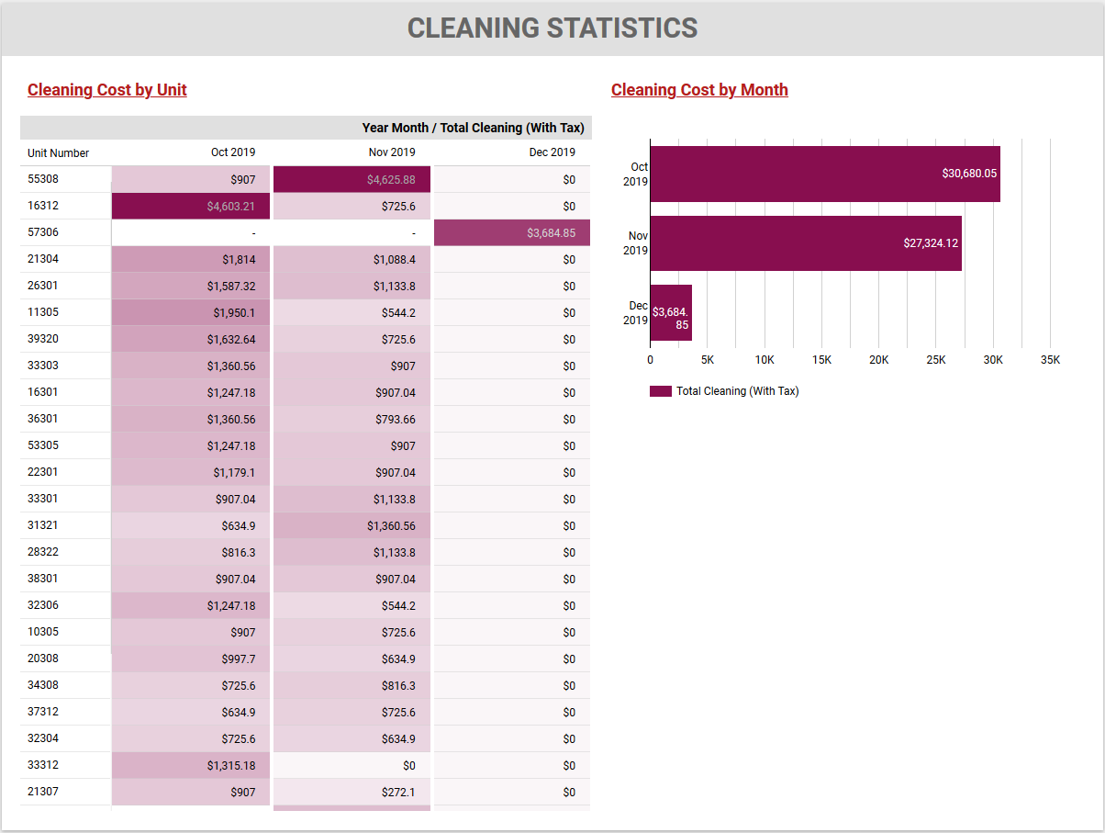

## Approach to Market Palm Place Villa

### Why do you market Palm Place Villa?

No matter how appealing the Palm Place villa is, it is how it is packaged and marketed that really catches the eye and captures the imagination. From the design details to the spectacular location, the Palm Place villa may be catwalk-ready to parade in front of the luxury villa rental market, but you still need to strut your stuff.

### Things the Real Estate Management company should do to market?

|  |  |  |
| --- | --- | --- |
| **#** |  | **Description** |
|  | **Strategy and Analysis** | Marketing goal, a strategy for achieving that target, and a way of analyzing the results. Marketing campaigns can be multi-faceted, reaching out to would-be vacationers through a variety of paid, earned, shared, and owned media channels. This all-encompassing approach and how each part of our marketing plays out needs to be pre-assessed so that it fits together and integrates.  A good place to start is to list things to be achieved and break it down into mini goals. Making sure to check results and allow for flexibility and change. Part of our marketing strategy is ensuring that other departments are delivering too, such as having the best reservation team in place. |
|  | **Website Management** | There is no room for a bad website in terms of words and images, design and navigation. From the coding to the content, our website needs to reflect the quality of our villa. It also needs to be regularly updated. There are so many defunct sites still online that browsers simply click off when they see offers and blogs looking past their sell-by date. Maintaining website also helps push it up the search rankings. |
|  | **Blogging and Copywriting** | Blogs are an excellent way to market villa and villa holidays in general; subjects such as reasons you need a villa holiday or how a villa vacation can change your life are great ways to reach out to the luxury market.  We are not just marketing our villa but the idea of villa holidays. Blogging is marketing, but it is blogging that gives readers some value too, from top tips to sound advice.  Our website content will be well-written. We will also send articles to other sites and press releases to magazines and other publications. These might be print versions and online editions, local, regional, and international. |
|  | **SEO** | Search Engine Optimization, or SEO, cannot be ignored. It is the way in which we can ensure our villa is ranked more highly in online search results. Writing content that integrates SEO through keywords. |
|  | **Social Media Management** | The big advantage of social media is that it is open to all. The disadvantage is everyone including your competitors are using it too. The main marketing code to keep in mind is to think about relevance. A well-placed quiz, beautiful images, or an appealing blog link on social media can be quickly shared. This means that our followers are accelerating our marketing strategy for us. |
|  | **Relationship Building** | Marketing requires solid relationships. This may mean getting to know complementary businesses in our area so that we can promote our villa on their site. Connecting with writers who have an interest in our part of the world, or the travel and hospitality industry, and even contributors to luxury-focused publications.  Just as much as we might want to sing the praises of our villa, there are other individuals and businesses willing to give a platform or even join in the chorus alongside. |
|  | **Paid Media Management** | This is one of the modern marketing strategies. This may be incorporated into search pages or through social media platforms such as Facebook and Twitter. One major advantage is that results are traceable, and costs are often low, meaning we can monitor success and steer marketing campaign accordingly. |
|  | **Creative Skills** | Nowadays there is a greater acceptance for blogs that are written by ‘real’ people talking about ‘real’ experiences. An experienced marketing editor can work wonders with raw copy too, polishing the content enough so it really shines. Marketing skills will include photography, graphics, and video content. A photograph accompanied by one sentence can pack a powerful marketing punch compared to reams of wordy text. |
|  | **Email Marketing** | E-blasts are an effective and affordable way to market villa. Taking a scatter-gun approach and aiming at a target, even if it is moving. Making an emailing list of potential clients.  In the luxury market it is not a numbers game, but about showing those who could be interested what we have to offer. A subscription sign-up or enquiry form on the website can drive contacts into our business more easily. |
|  | **Event Planning** | Creating online ‘events’ or real-life events to market our villa, such as invitations to visit our villa or a competition to win a villa stay, for example. Marketing our villa at certain pre-existing events, such as at exhibitions, interacting with villa seekers face-to-face, or asking our marketing team. Being proactive and putting assets out there adds to interest levels as we will be showing what our villa has to offer. |

### Approach to attracting sponsors

The Real Estate Management company should take the following approach to effective market Palm Place villa:

**1. Creating a list of ideal sponsors/prospects**

Thinking about the needs of our attendees, listing companies who meet those needs, and like that we will end up with a broad range of potential sponsors/prospects.

**2. Using digital tools**

Event planners could find sponsors and sponsors could find event planners. Building a professional brand image is a digital way to introduce new audience to your organization. This promotes brands and products online, which is digital marketing.

**3. Crafting a sponsorship proposal**

* Ticket and registration sales: Using attendance records to see how many people a sponsor could reach and how much our event has grown each year.
* Demographics: Sponsors want to know their audience’s age, gender, and location, but we can go even deeper with education level, job title, and income to show purchasing power.
* Non-attendee demographics: Gather information about vendors and media at our event, especially which audiences they appeal to.
* Social media actions: Track when, where, and how often our event is mentioned on a website, blog, social network, or news site.

**4. Connecting with event sponsors**

* Draft an elevator pitch: Writing two to three lines about the types of events which can be held at our villa, the value to a potential sponsor, and a request for a short meeting.
* Connect with prospects: Connecting with sponsors by attending events, interacting on social media, reaching out on LinkedIn, or sending emails.
* Follow up kindly: Reiterating the value statement and asking to meet.
* Meet and listen: Listening to sponsors and take notes about what they want to customize in our proposal.

**5. Designing our events to attract sponsors**

* Customize proposal: Using what we’ve learned about their objectives to show how our villa can help achieve their goals and justify the spend.
* Get them excited: Creating a one-of-a-kind event experience with an experiential marketing campaign.

**6. Building a long-term relationship to keep sponsors**

* Satisfying the needs of our sponsors so they come back to build exciting experiences attendees love.
* Once a proposal has been accepted, make a checklist so that we keep the promises that have been made.
* Keeping sponsors informed and involved leading up to the event.
* Staying flexible.
* Being a generous host. If we can extend VIP amenities or other positive experiences to sponsor employees, we will do it.